Exercise 1: Creating a react app “cricketapp”

1. Open ‘Command prompt’ and type in the command to create a new react app named ‘cricketapp’

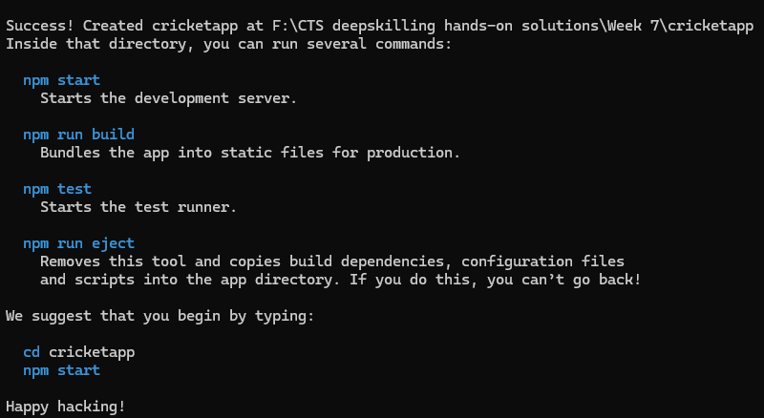

after all packages are installed we get this success message.

2. Now we open the project folder in Visual Studio Code

3. In src folder we create a new folder called ‘components’, inside which we create ListOfPlayers.js

import React from 'react';

const ListofPlayers = () => {

  const players = [

    { name: "Virat", score: 95 },

    { name: "Rohit", score: 85 },

    { name: "Dhoni", score: 65 },

    { name: "Hardik", score: 55 },

    { name: "Raina", score: 75 },

    { name: "KL Rahul", score: 45 },

    { name: "Jadeja", score: 80 },

    { name: "Shami", score: 35 },

    { name: "Bumrah", score: 60 },

    { name: "Ashwin", score: 70 },

    { name: "Surya", score: 90 },

  ];

  const filteredPlayers = players.filter(player => player.score < 70);

  return (

    <div>

      <h2>All Players</h2>

      <ul>

        {players.map((player, index) => (

          <li key={index}>{player.name} - {player.score}</li>

        ))}

      </ul>

      <h3>Players with score below 70:</h3>

      <ul>

        {filteredPlayers.map((player, index) => (

          <li key={index}>{player.name} - {player.score}</li>

        ))}

      </ul>

    </div>

  );

};

export default ListofPlayers;

4. Inside the components folder create another component ‘IndianPlayers.js’

import React from 'react';

const IndianPlayers = () => {

  const T20players = ["Virat", "Rohit", "Pant", "Bumrah"];

  const RanjiTrophy = ["Gambhir", "Pujara", "Rahane", "Ashwin"];

  const allPlayers = [...T20players, ...RanjiTrophy];

  const oddPlayers = allPlayers.filter((_, index) => index % 2 !== 0);

  const evenPlayers = allPlayers.filter((_, index) => index % 2 === 0);

  return (

    <div>

      <h2>All Indian Players</h2>

      <ul>

        {allPlayers.map((player, index) => <li key={index}>{player}</li>)}

      </ul>

      <h3>Odd Team</h3>

      <ul>

        {oddPlayers.map((name, i) => <li key={i}>{name}</li>)}

      </ul>

      <h3>Even Team</h3>

      <ul>

        {evenPlayers.map((name, i) => <li key={i}>{name}</li>)}

      </ul>

    </div>

  );

};

export default IndianPlayers;

5. Modify the ‘App.js’ file to render these components

import React from 'react';

import ListofPlayers from './components/ListOfPlayers';

import IndianPlayers from './components/IndianPlayers';

function App() {

  const flag = true;

  return (

    <div className="App">

      <h1>🏏 Cricket App</h1>

      {flag ? <ListofPlayers /> : <IndianPlayers />}

    </div>

  );

}

export default App;

**OUTPUT(Console)**

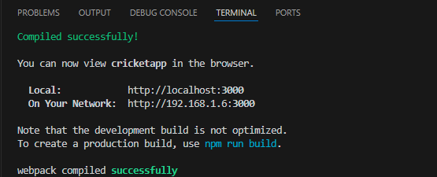

**OUTPUT(Browser)**

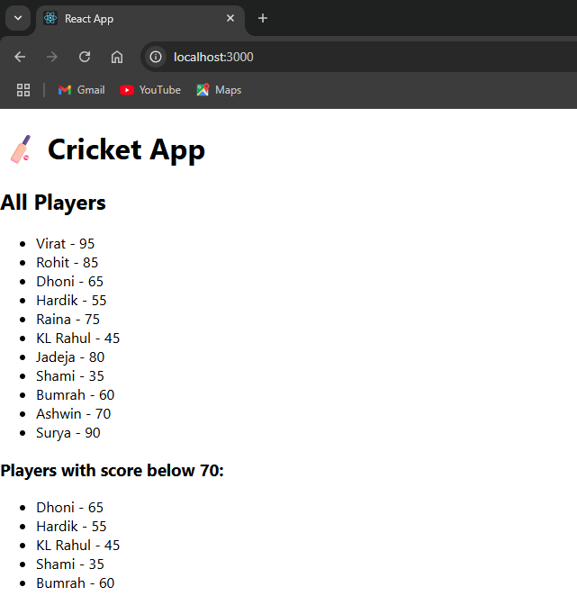

If we change the flag to “false”

**OUTPUT(Browser)**

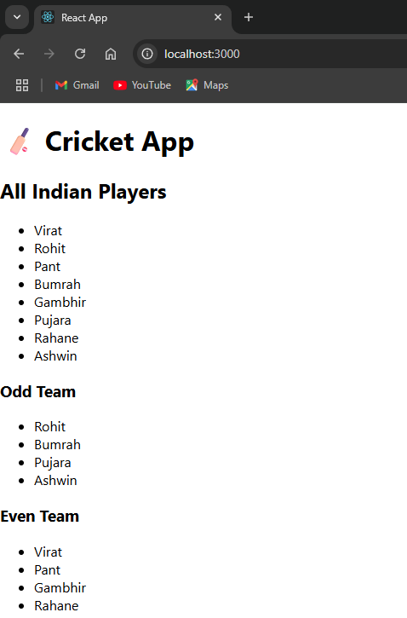

Exercise 2: Creating a react app “office-space-rental-app”

1. Open ‘Command prompt’ and type in the command to create a new react app named ‘officespacerentalapp’

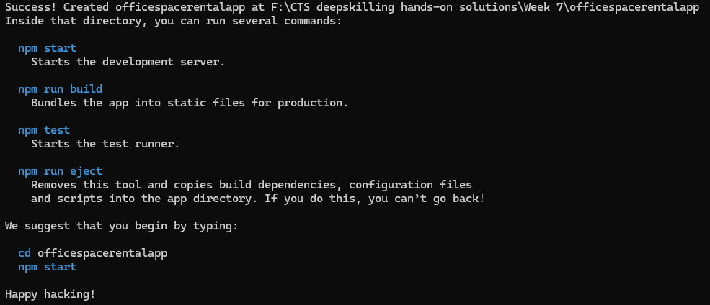

after all packages are installed we get this success message.

2. Now we open the project folder in Visual Studio Code

3. We modify the “App.js” to use inline CSS and JSX to render the Office Image, Name, Address and Rental cost

import React from 'react';

function App() {

  const offices = [

    {

      id: 1,

      name: 'Tech Park Tower',

      rent: 55000,

      address: '12th Street, Thilakar Nagar, Chennai',

      image: './officeimg3.jpg'

    },

    {

      id: 2,

      name: 'Green Field Building',

      rent: 70000,

      address: '45th Avenue, Choolaimedu, Chennai',

      image: './officeimg2.jpg'

    },

    {

      id: 3,

      name: 'Blue Ocean Offices',

      rent: 62000,

      address: 'Mettu Street, Egmore, Chennai',

      image: './officeimg1.jpg'

    }

  ];

  const headingStyle = {

    textAlign: 'center',

    color: '#333'

  };

  return (

    <div>

      <h1 style={headingStyle}>Office Space Rental App</h1>

      {offices.map((office) => (

        <div key={office.id} style={{ border: '1px solid #ccc', margin: '10px', padding: '10px' }}>

          <img src={office.image} alt={office.name} width="300" height="200" />

          <h2>{office.name}</h2>

          <p><strong>Address:</strong> {office.address}</p>

          <p>

            <strong>Rent:</strong>{' '}

            <span style={{ color: office.rent < 60000 ? 'red' : 'green' }}>

              ₹{office.rent}

            </span>

          </p>

        </div>

      ))}

    </div>

  );

}

export default App;

4. Now we run the app using “npm start” command in the terminal

**OUTPUT(Console)**

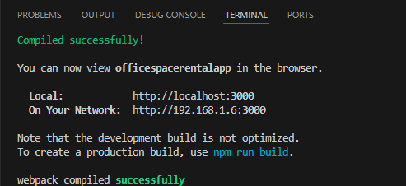

**OUTPUT(Browser)**

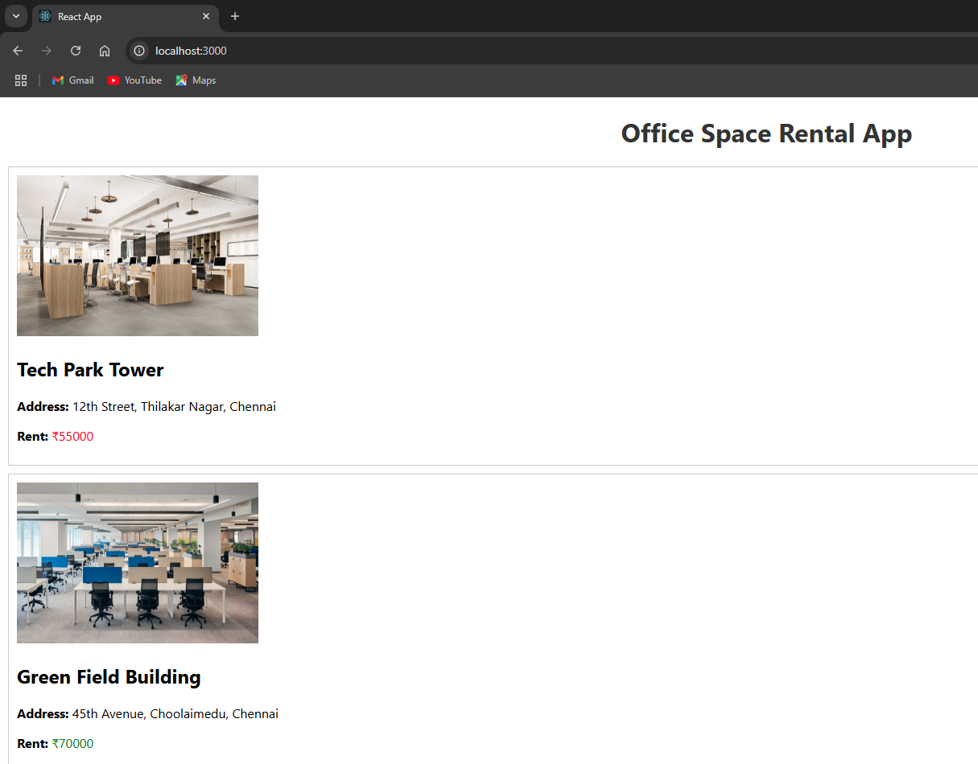

Exercise 3: Creating a react app “event-example-app”

1. Open ‘Command prompt’ and type in the command to create a new react app named ‘eventexampleapp’

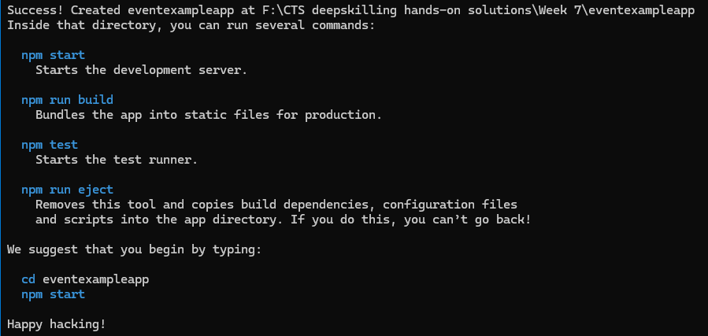

after all packages are installed we get this success message.

2. Now we open the project folder in Visual Studio Code

3. In src folder we create a new folder called ‘components’, inside which we create the following components, “SayWelcome.js”, “OnPressButton.js”, “CurrencyConverter.js”

SayWelcome.js

import React from 'react';

function SayWelcome() {

  function sayHi() {

    alert("Welcome to React Event Handling!");

  }

  return (

    <div style={{ marginBottom: "20px" }}>

      <h2>Say Welcome Component</h2>

      <button onClick={sayHi}>Say Welcome</button>

    </div>

  );

}

export default SayWelcome;

OnPressButton.js

import React from 'react';

function OnPressButton() {

  const pressHandler = () => {

    alert("You pressed the button!");

  };

  return (

    <div style={{ marginBottom: "20px" }}>

      <h2>On Press Button Component</h2>

      <button onClick={pressHandler}>Press Me</button>

    </div>

  );

}

export default OnPressButton;

CurrencyConverter.js

import React, { useState } from 'react';

function CurrencyConvertor() {

  const [inr, setInr] = useState(0);

  const [usd, setUsd] = useState(0);

  const convertCurrency = () => {

    const converted = inr / 83;

    setUsd(converted.toFixed(2));

  };

  return (

    <div style={{ marginBottom: "20px" }}>

      <h2>Currency Converter</h2>

      <input

        type="number"

        placeholder="Enter INR"

        value={inr}

        onChange={(e) => setInr(e.target.value)}

      />

      <button onClick={convertCurrency} style={{ marginLeft: "10px" }}>

        Convert to USD

      </button>

      <p>USD: ${usd}</p>

    </div>

  );

}

export default CurrencyConvertor;

5. Modify the ‘App.js’ file to render these components

import React from 'react';

import Counter from './components/Counter';

import SayWelcome from './components/SayWelcome';

import OnPressButton from './components/OnPressButton';

import CurrencyConverter from './components/CurrencyConverter';

function App() {

  return (

    <div>

      <h1>Event Examples App</h1>

      <Counter />

      <SayWelcome />

      <OnPressButton />

      <CurrencyConverter />

    </div>

  );

}

export default App;

**OUTPUT(Console)**

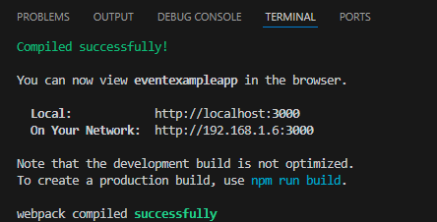

**OUTPUT(Browser)**

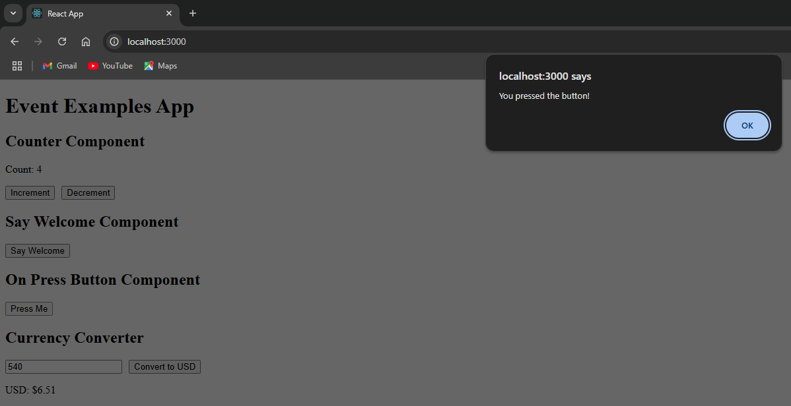

Exercise 4: Creating a react app “ticket-booking-app”

1. Open ‘Command prompt’ and type in the command to create a new react app named ‘ticketbookingapp’

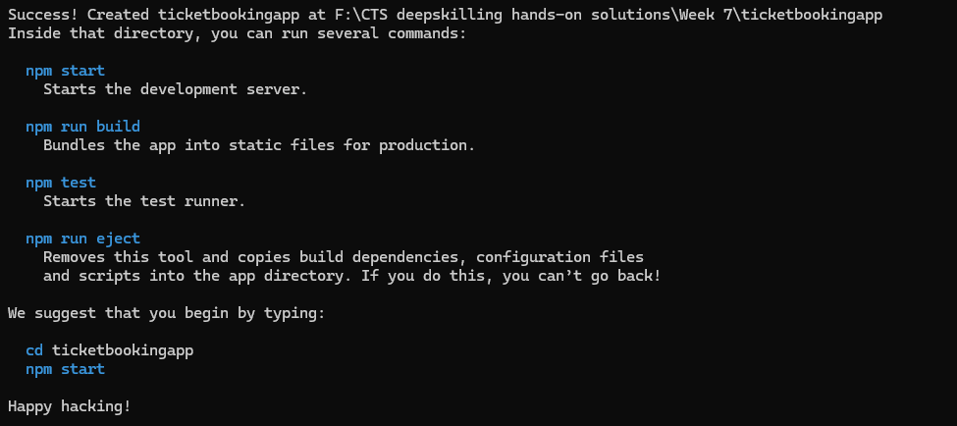

after all packages are installed we get this success message.

2. Now we open the project folder in Visual Studio Code

3. In src folder we create a new folder called ‘components’, inside which we create the following components GuestPage.js, UserPage.js, LoginControl.js

GuestPage.js

import React from "react";

function GuestPage() {

  return (

    <div>

      <h2>Welcome Guest!</h2>

      <p>Please login to book your flight tickets.</p>

    </div>

  );

}

export default GuestPage;

UserPage.js

import React from "react";

function UserPage() {

  return (

    <div>

      <h2>Welcome User!</h2>

      <p>You can now book your flight tickets.</p>

    </div>

  );

}

export default UserPage;

LoginControl.js

import React, { useState } from "react";

import GuestPage from "./GuestPage";

import UserPage from "./UserPage";

function LoginControl() {

  const [isLoggedIn, setIsLoggedIn] = useState(false);

  const handleLogin = () => setIsLoggedIn(true);

  const handleLogout = () => setIsLoggedIn(false);

  let page = isLoggedIn ? <UserPage /> : <GuestPage />;

  let button = isLoggedIn ? (

    <button onClick={handleLogout}>Logout</button>

  ) : (

    <button onClick={handleLogin}>Login</button>

  );

  return (

    <div>

      {button}

      {page}

    </div>

  );

}

export default LoginControl;

4. Now we modify the “App.js” and render these components

import React from "react";

import LoginControl from "./components/LoginControl";

function App() {

  return (

    <div className="App" style={{textAlign:'center'}}>

      <h1>✈️ Flight Ticket Booking App</h1>

      <LoginControl />

    </div>

  );

}

export default App;

**OUTPUT(Console)**

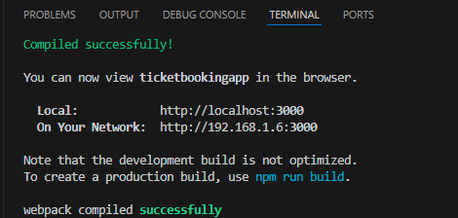

**OUTPUT(Browser – Before Login)**

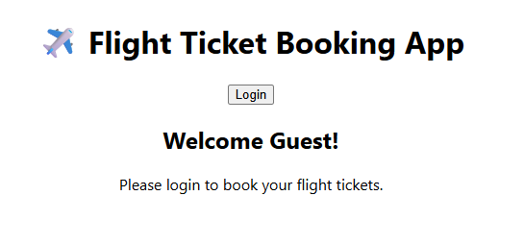

**OUTPUT(Browser – After Login)**

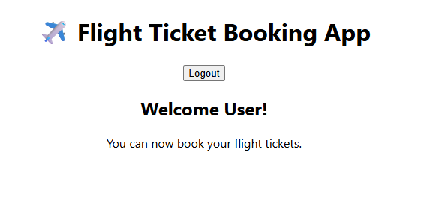

Exercise 5: Creating a react app “blogger-app”

1. Open ‘Command prompt’ and type in the command to create a new react app named ‘bloggerapp’

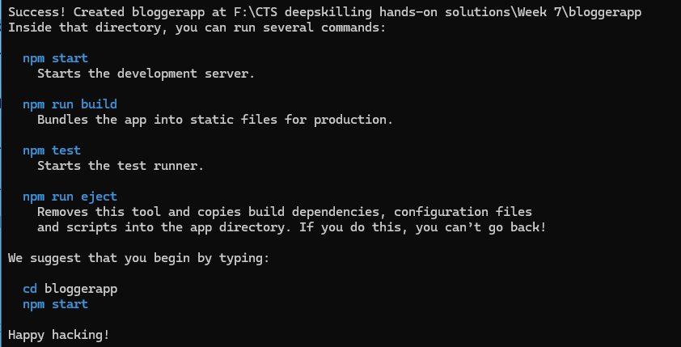

after all packages are installed we get this success message.

2. Now we open the project folder in Visual Studio Code

3. In src folder we create a new folder called ‘components’, inside which we create the following components BookDetails.js, BlogDetails.js, CourseDetails.js

BookDetails.js

import React from "react";

const BookDetails = () => (

  <div>

    <h2>Book Details</h2>

    <p>This section contains information about books.</p>

  </div>

);

export default BookDetails;

BlogDetails.js

import React from "react";

const BookDetails = () => (

  <div>

    <h2>Blog Details</h2>

    <p>This section contains information about blogs.</p>

  </div>

);

export default BookDetails;

CourseDetails.js

import React from "react";

const BookDetails = () => (

  <div>

    <h2>Course Details</h2>

    <p>This section contains information about courses.</p>

  </div>

);

export default BookDetails;

4. Now we modify the “App.js”

import React, { useState } from "react";

import BookDetails from "./components/BookDetails";

import BlogDetails from "./components/BlogDetails";

import CourseDetails from "./components/CourseDetails";

function App() {

  const [view, setView] = useState("book");

  const renderComponent = () => {

    if (view === "book") return <BookDetails />;

    else if (view === "blog") return <BlogDetails />;

    else if (view === "course") return <CourseDetails />;

    else return <p>Select a section</p>;

  };

  return (

    <div>

      <h1>Blogger App</h1>

      <button onClick={() => setView("book")}>Book Details</button>

      <button onClick={() => setView("blog")}>Blog Details</button>

      <button onClick={() => setView("course")}>Course Details</button>

      <hr />

      {renderComponent()}

    </div>

  );

}

export default App;

**OUTPUT(Console)**

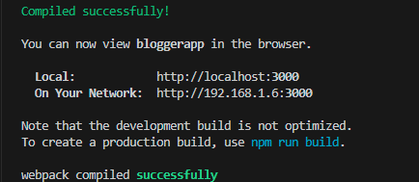

When clicked on each button that respective component is rendered

**OUTPUT 1(Browser)**

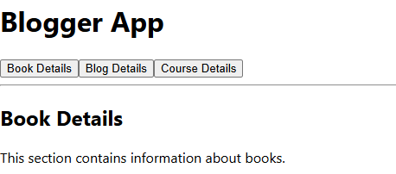

**OUTPUT 2(Browser)**

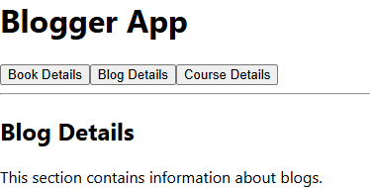

**OUTPUT 3(Browser)**

